

Assignment Report

|  |  |  |
| --- | --- | --- |
| COURSE CODE | : | BTPR2053 |
| COURSE | : | Fundamental of Image Processing |
| SEMESTER & YEAR | : | Semester 1 2020 |
| INSTRUCTOR | : | Pang Yee Yong |

|  |  |  |
| --- | --- | --- |
| Nama | Student ID | Batch |
| Mok Yau Chun | B180276C | BoSE18-C2 |

**Assignment 1**

**Input:**



**Output:**

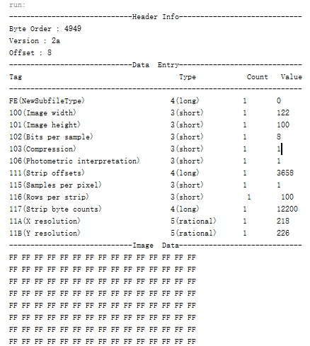

**Assignment 2**

**Input:**

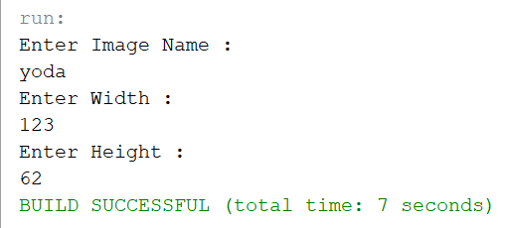

**Output:**



Yoda.raw

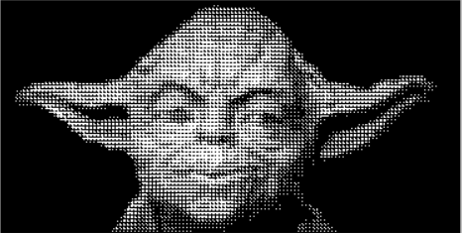

yoda_pattern.raw

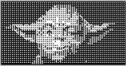

yoda_D1.raw

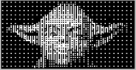

yoda_D2.raw

**Assignment 3**

**Input:**

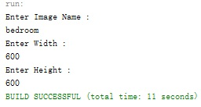

**Output:**

**Before**

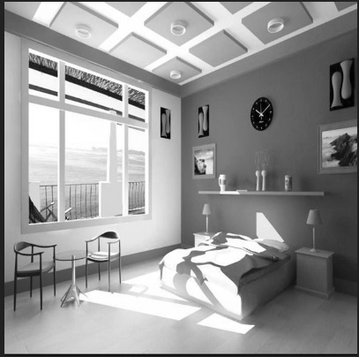

Bedroom.raw

**After**

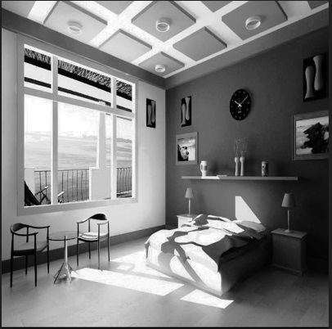

Bedroom_second.raw

**Assignment 4**

**Input:**

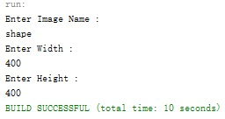

**Output:**

**Before**

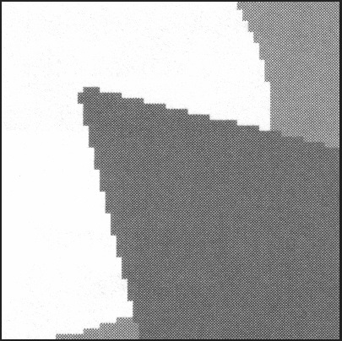

shape.raw

**After**

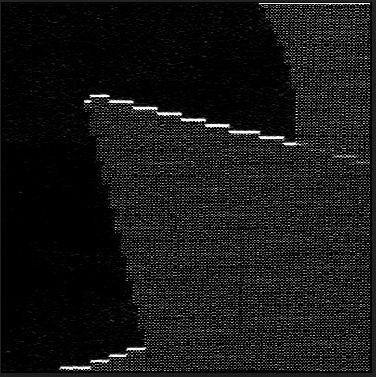

shape_second.raw

**Assignment 5**

**Input:**

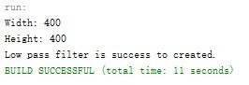

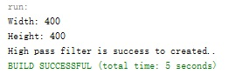

**Output:**

**Before**



shape.raw

**After**

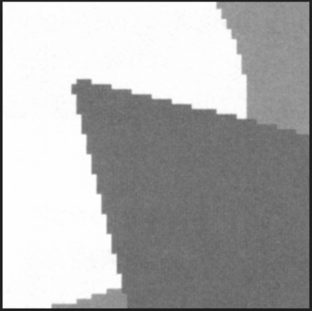

shape_Low.raw

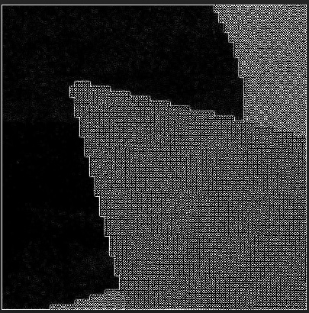

shape_High.raw